EBAR Tools Documentation

Contents

Background 2

Usage 2

Tool Parameters and Tips 3

Add Synonyms Tool 3

Generate Range Map Tool 3

Import External Range Review Tool 5

Import Spatial Data Tool 7

Import Tabular Data Tool 7

List Element National IDs Tool 8

Sync Species List Biotics Tool 9

Sync Species List KBA Tool 9

Tools in Development 10

Build Download Table Tool 10

Publish Range Map Tool 10

Publish Range Maps Data Tool 10

Species Sync Workflow 10

Design Notes 11

Source Code Control and Editing 11

# Background

For general EBAR project background please see <https://www.natureserve.org/natureserve-network/canada/biodiversity-data/ebar-range-mapping/ebar-maps> and <https://www.natureserve.org/natureserve-network/canada/biodiversity-data/ebar-range-mapping/ebar-maps>.

# Usage

Tools published to the EBAR Tools geoprocessing service run against the production ebarkba geodatabase. Access tools in ArcGIS Pro via the Portal tab in the Catalog Pane:

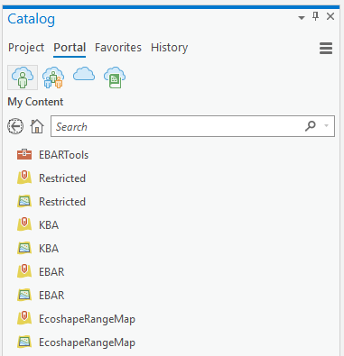

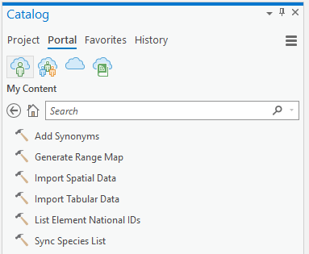

# Tool Parameters and Tips

## Add Synonyms Tool

Add BIOTICS Synonyms not already in the Species or Synonym tables

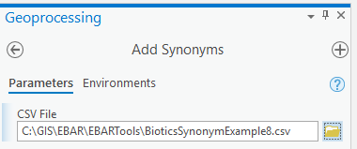

CSV File: a file of Biotics synonyms created using the query “OneDrive\EBAR\Data Mining\Species Prioritization\Biotics Sync\BioticsSynonymDownloadSQLWithShortCitation.txt”.

Build Bulk Download Table Tool

Builds a html table of per category/taxa EBAR PDF and Spatial Data zip links to be embedded in <https://www.natureserve.org/natureserve-network/canada/biodiversity-data/ebar-range-mapping/ebar-maps>.

No parameters, uses IncludeInDownloadTable field.

Build EBAR Download Table Tool

Builds a html table of per species EBAR PDF and ZIP downloads links to be embedded in <https://www.natureserve.org/natureserve-network/canada/biodiversity-data/ebar-range-mapping/ebar-maps>.

No parameters, uses IncludeInDownloadTable field.

## Generate Range Map Tool

Generate Range Map for a species from available spatial data and from review records marked with UseForMapGen=1.

In addition to creating/updating records in the RangeMap, RangeMapEcoshape and RangeMapEcoshapeInputDataset tables,iInput data that can be viewed by reviewers in the EBAR Reviewer app is saved in the RangeMapInput table, with restrictions implemented as follows:

* Records with InputDataset.Restrictions = E (Restricted EBAR) are never visible in EBAR Reviewer
* Records with InputDataset.Restrictions = N (Non-restricted) are always visible in EBAR Reviewer
* Records with InputDataset.Restrictions = R (Restricted) are only visible in EBAR Reviewer if their DatasetSource.CDCJurisctionID is not null AND the species is not included in the RestrictedJurisdictionSpecies table.

For CDCs that have agreed to allow their otherwise restricted data (see InputDataset.Restrictions described below in the Import Toos) to be shown in the EBAR Reviewer app, provide the CDCJurisdictionID in the appropriate DatasetSource records(s). For CDCs with exceptional species that should never be shown in the EBAR Reviewer app, create a RestrictedJurisdictionSpecies record for each CDC/species combination. The following table summarizes the rules:

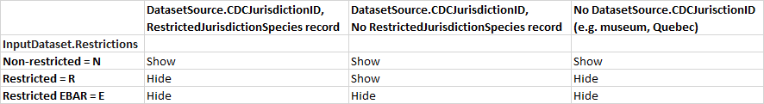

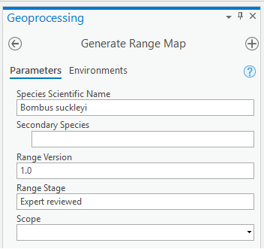

Species Scientific Name: name of the primary species for the range map (see BIOTICS_ELEMENT_NATIONAL table for valid values).

Secondary Species (optional): one or more additional species to be included in the range map (see BIOTICS_ELEMENT_NATIONAL table for valid values).

Range Version: a label for the version of the range map, to allow multiple versions/stages to be created over time (note that field IncludeInEBARReviewer determines which range maps are available in the EBAR Reviewer web app).

Range Stage: a label for the stage within version of the range map, to allow multiple versions/stages to be create over time.

Scope (optional): the geographic coverage of the range map (National, Global, North American). If National is selected, only those Ecoshapes in Canada are included in the output.

## Import External Range Review Tool

Creates review records for an existing range map based on third-party polygons, as if the review had been performed using the EBAR Reviewer.

A range map must be generated before this tool can be used. Subsequent range maps for the combination of species, range version and stage will apply the review records created by this tool (i.e. they will have UseForMapGen set to 1).

The External Review Polygons must have an EcoshapeID field that matches the EBAR EcoshapeID values. If necessary (for instance if the range was generated using an older version of the Ecoshapes), this can be done in pre-processing, for example:

* If there is a good match with Ecoshape names, run an Add Join based on name and Keep All Target Features. Be careful with this approach because some Ecoshape names are repeated across jurisidictions!
* If Ecoshape name matching is not possible, running Spatial Join with Ecoshapes as the Target Features and the External Review Polygons as the Join Features, Keeping All Target Features and with the Are Identical To match option.
* For all matched/joined records calculate a new EcoshapeID field in the External Review Polygons.
* For unjoined Ecoshapes, if any, comparing them to the External Review Polygons and:
  + If using Presence field, setting it appropriately.
  + If not using a Presence field, deleting Ecoshapes that are not part of the range.

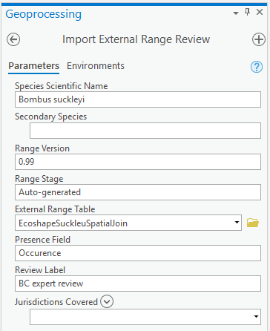

Species Scientific Name: the primary Species for the Range Map to apply the review to.

Secondary Species: additional Species included in the Range Map to apply the review to.

Range Version: version label, which together with Species and Stage, uniquely identifies the Range Map to apply the review to.

Range Stage: stage of the Range Map to apply the review to.

External Range Table: table containing the EcoshapeIDs that constitute the results of the external review. If necessary, for example if there are multiple species in the same dataset, use a Definition Query or Select by Attributes to limit the records to be used. See the pre-processing notes above for information on creating this table.

Presence Name Field (optional): name of the field in the External Range Table containing the reviewed Presence value for the Ecoshape. If not provided, all External Range Polygons are assumed to be Present.

Review Label: descriptive label to be recorded with the review records.

Jurisdictions Covered (optional): one or more jurisdictions indicating the extent of the external review (only ecoshapes within the selected jurisdictions(s) will be marked up in the review); if not provided, all jurisdictions are used for the extent.

Username: the username from the Expert table to assigned to the review records

## Import Spatial Data Tool

Imports spatial data from a shapefile or feature class into the InputDataset table of the EBAR geodatabase and one of the InputPolygon, InputPoint or InputLine feature classes.

Import tool results are being tracked at “OneDrive\EBAR_Sensitive_Material\RG Import Logs.txt” and “OneDrive\EBAR_Sensitive_Material\CT_ImportLogs.txt”.

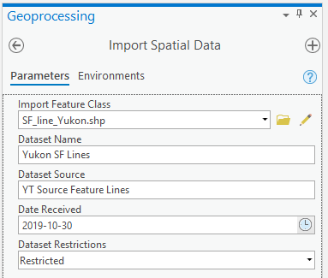

Import Feature Class: point, line or polygon shape file or file geodatabase feature class containing the species data to be imported.

Dataset Name: descriptive label for the database (combined with Dataset Source and Date Received, uniquely identifies an InputDataset).

Dataset Source: the name of the specification for the dataset source (see DatasetSource table for specifications details and valid values).

Date Received: the data the dataset was received.

Dataset Restrictions: an indicator of restrictions, if any, on use of the data, as follows:

* Non-restricted – no restrictions.
* Restricted – can be accessed by members of the EBAR-KBA team assuming security requirements for the dataset have been met.
* Restricted EBAR – can only be accessed by NatureServe Canada members of the EBAR project.

## Import Tabular Data Tool

Imports tabular data into the InputDataset and InputPoint tables of the EBAR geodatabase

Import tool results are being tracked at “OneDrive\EBAR_Sensitive_Material\RG Import Logs.txt” and “OneDrive\EBAR_Sensitive_Material\CT_ImportLogs.txt”.

If a tabular dataset to be imported does not have an existing field mapping (see field mappings in Design Notes below), one option is to rename/add CSV fields to match those in the “Other” field mapping. After importing using the “Other” field mapping, create a new DatasetSource record with the correct name and citation for the source, then edit InputDataset.DatasetSourceID to match the new DatasetSource.

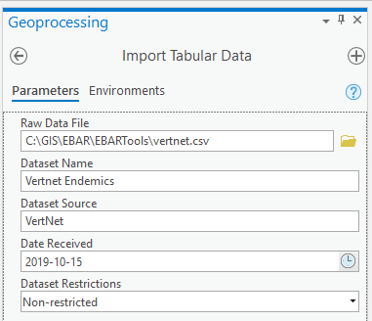A

Raw Data File: file containing point species data to be imported.

Dataset Name: descriptive label for the database (combined with Dataset Source and Date Received, uniquely identifies an InputDataset).

Dataset Source: the name of the specification for the dataset source (see DatasetSource table for specifications details and valid values).

Date Received: the data the dataset was received.

Dataset Restrictions: an indicator of restrictions, if any, on use of the data, as follows:

* Non-restricted – no restrictions.
* Restricted – can be accessed by members of the EBAR-KBA team assuming security requirements for the dataset have been met.
* Restricted EBAR – can only be accessed by NatureServe Canada members of the EBAR project.

## List Element National IDs Tool

Lists existing ELEMENT_NATIONAL_ID values from the BIOTICS_ELEMENT_NATIONAL table of the ebarkba geodatabase. ID values can be copied (up to 1000 at a time) and used with the query “OneDrive\EBAR\Data Mining\Species Prioritization\Biotics Sync\ BioticsSpeciesDownloadSQLWithShortCitation.txt” to generate input file for the Sync Species List tool (see below).

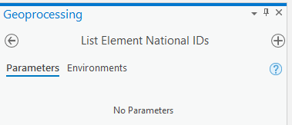

## Sync Species List Biotics Tool

Synchronize the BIOTICS_NATIONAL_ELEMENT and Species tables with Biotics.

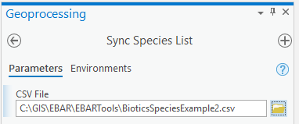

CSV File: a file of one or more Biotics species created using the query “OneDrive\EBAR\Data Mining\Species Prioritization\Biotics Sync\BioticsSpeciesDownload.txt”. Existing species (based on ELEMENT_NATIONAL_ID) in the BIOTICS_ELEMENT_NATIONAL table of the ebarkba geodatabase will be updated, and new species will be added.

## Sync Species List KBA Tool

Synchronize the Species table with BIOTICS_NATIONAL_ELEMENT table and update the Species table with fields used to identify KBA trigger species based on WCS KBA research.

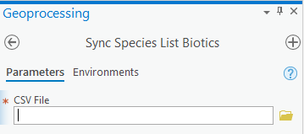

CSV File: a file created in R from multiple queries to determine KBA trigger species. Existing species are matched based on ELEMENT_NATIONAL_ID to the BIOTICS_ELEMENT_NATIONAL table of the ebarkba geodatabase. Records in the species table will be updated, and new species will be added, if there is a successful match.

# Tools in Development

## Publish Range Map Tool

Creates JPG, PDF and Spatial Data (ZIP) for a single EBAR RangeMap.

Working locally, requires ArcGIS Server upgrade before server deployment due to use of new arcpy libraries.

Range Map ID: RangeMapID of the RangeMap to be published.

Output GIS Data Zip: boolean flag indicating that a Zip file of spatial data will be created.

## Publish Range Maps Sets Tool

Creates a Spatial Data (ZIP) package for multiple EBAR RangeMaps with the same Category/Taxa.

In development.

Uses IncludeInDownloadTable field.

Category Taxa Label [optional]: the Biotics category/taxa label for the RangeMap spatial data package to be created, or None for all published RangeMaps; may forego this parameter and automatically create for each category/taxa and overall.

# Species Sync Workflow

* Get CSV output file of species and KBA information (existing and new) generated from Chloe's R code (Chloe currently does this).
* Run Sync Species List KBA tool passing in the CSV file from the previous step. This syncs KBA fields for existing species and outputs a list of ElementNationalIDs for new species (i.e. those not in the EBAR database).
* Run List Element National IDs tool to get the list of IDs for existing species.
* Login to Central Biotics (<https://bioticscentral.natureserve.org/biotics/login.jsp>) using a web browser and run the Biotics Species Download and Biotics Synonym Download queries (available at “OneDrive\EBAR\Data Mining\Species Prioritization\Biotics Sync”), passing in the lists of ElementNationalIDs and downloading the output CSVs (this is done in batches because the query allows a maximum of 1000 species at a time).
* Run Sync Species List Biotics tool, which syncs Biotics fields.
* Run Add Synonyms tool, which adds any new synonyms for our species.
* Run Sync Species List KBA tool again, to sync KBA fields for new species.

# Design Notes

* For tabular DatasetSourceTypes, the Import Tabular Data tool uses field mappings defined in TabularFieldMapping.py to translate between the fields of the DatasetSource (GBIF, VertNet, etc.) and the InputPoint table.
* For spatial DatasetSourceTypes, the Import Spatial Data tools use field mappings defined in the DatasetSource table (field names ending with “Field”) to translate between the fields of the DatasetSource (provincial CDC, state NHP, etc.) and the InputPoint/Line/Polygon tables.
* Spatial Datasets must also be given a DatasetType in the DatasetSource table, with values as follows:
  + Area of Occupancy (used for KBA only, not used for EBAR) – polygons depicting the known occupancy locations for a species, similar to a range estimate.
  + Critical Habitat – polygon areas of critical habitat from an authoritative source, such as a species recovery plan.
  + Element Occurrences – point, line or polygon EOs from a NatureServe member program (CDC or NHP).
  + Habitat Suitability – polygon areas of suitable habitat from an authoritative source, such as a NatureServe HSM.
  + Other Range (used for KBA only, not used for EBAR) – polygon estimate of existing species range.
  + Range Estimates – polygon estimate of existing species range from an authoritative source, such as a peer reviewed paper.
  + Source Features – point SFs from a NatureServe member program.
  + Species Observations – point observations.

# Source Code Control and Editing

See <https://github.com/NatureServe-Canada/EBARTools> for source code. Regularly check code changes into this repository.

Recommended to use an interactive development environment (IDE), such as Visual Studio (<https://visualstudio.microsoft.com/vs/community/>) or PyCharm (<https://www.jetbrains.com/pycharm/>) to facilitate interactive debugging. The Python file for each tool (e.g. ImportTabularDataTool.py) contains a controlling process at the end which allows you to start the tool by running that file, passing parameters for debugging.